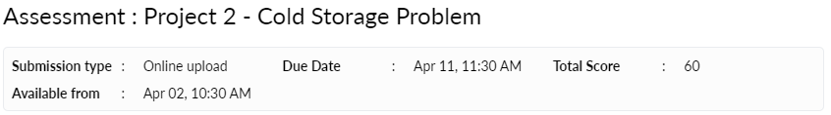

**Description**

Dear Learner,

Please find below Project instructions:

* Your submission will contain two parts-
  1. A Report containing answers to questions asked and techniques performed. It should contain the results of your analysis. This will also include the insights unearthed during the course of solving the problem, visualizations to support the results and the recommendations based on the analyses conducted. The format can be PDF/ Doc for the same.
  2. R file that has all the codes used in Analysis with comments.
* Any assignment found copied/ plagiarized with another person will not be graded and marked as zero.
* Please ensure timely submission as post-deadline assignment submission will not be accepted.

Problem 1

Cold Storage started its operations in Jan 2016. They are in the business of storing Pasteurized Fresh Whole or Skimmed Milk, Sweet Cream, Flavoured Milk Drinks. To ensure that there is no change of texture, body appearance, separation of fats the optimal temperature to be maintained is between 2 - 4 C.

In the first year of business, they outsourced the plant maintenance work to a professional company with stiff penalty clauses. It was agreed that if it was statistically proven that the probability of temperature going outside the 2 - 4 C during the one-year contract was above 2.5% and less than 5% then the penalty would be 10% of AMC (annual maintenance contract). In case it exceeded 5% then the penalty would be 25% of the AMC fee. The average temperature data at date level is given in the file “Cold_Storage_Temp_Data.csv”

1. Find mean cold storage temperature for Summer, Winter and Rainy Season (3 marks)
2. Find overall mean for the full year (3 marks)
3. Find Standard Deviation for the full year (3 marks)
4. Assume Normal distribution, what is the probability of temperature having fallen below 2 C? (6 marks)
5. Assume Normal distribution, what is the probability of temperature having gone above 4 C? (6 marks)
6. What will be the penalty for the AMC Company? (7 marks)
7. Perform a one-way ANOVA test to determine if there is a significant difference in Cold Storage temperature between rainy, summer and winter seasons and comment on the findings. (9 marks)

Problem 2

In Mar 2018, Cold Storage started getting complaints from their clients that they have been getting complaints from end consumers of the dairy products going sour and often smelling. On getting these complaints, the supervisor pulls out data of the last 35 days’ temperatures. As a safety measure, the Supervisor decides to be vigilant to maintain the temperature at 3.9 C or below.

Assume 3.9 C as the upper acceptable value for mean temperature and at alpha = 0.1. Do you feel that there is a need for some corrective action in the Cold Storage Plant or is it that the problem is from the procurement side from where Cold Storage is getting the Dairy Products? The data of the last 35 days is in “Cold_Storage_Mar2018.csv”

1. Which Hypothesis test shall be performed to check if corrective action is needed at the cold storage plant? Justify your answer. (8 marks)
2. State the Hypothesis, perform hypothesis test and determine p-value (11 marks)
3. Give your inference (4 marks)

Please use the following datasets

Problem 1: Use only the dataset: Cold_Storage_Temp_Data.csv,

Problem 2: Use only the dataset: Cold_Storage_Mar2018.csv

Please note the following:

1. There are two parts to the submission:
   1. The output/report in any file format - the key part of the output is the set of observations and insights from the exploration and analysis
   2. Commented R code in .R or .Rmd
2. Please don’t share your R code and/or outputs only, we expect some verbiage/story too - a meaningful output that you can share in a business environment
3. Any assignment found copied/ plagiarized with other groups will not be graded and awarded zero marks
4. Please ensure timely submission as post-deadline assignment will not be accepted

Thanks

Program Office

